Zoo database table structures

Admin table

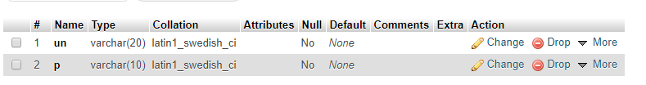

Staff table

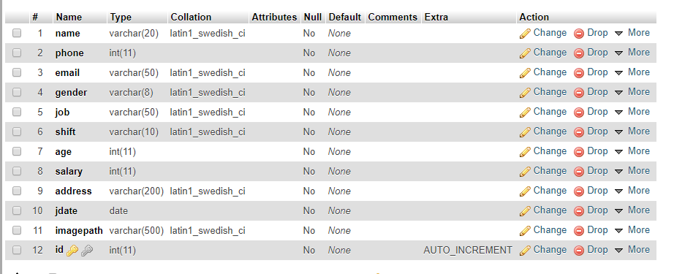

Donor table

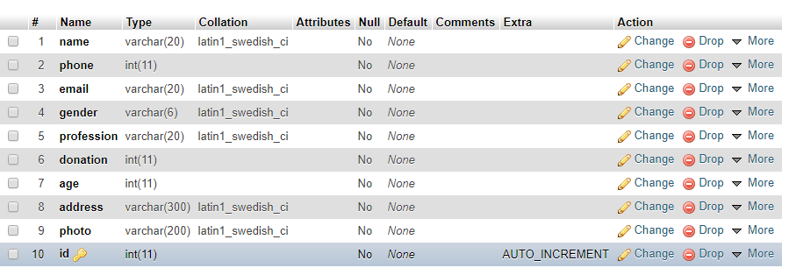

Animal table

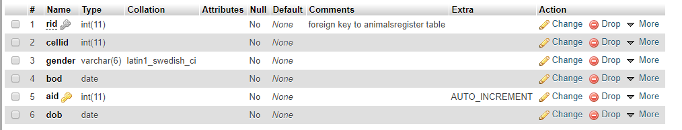

Animals register table

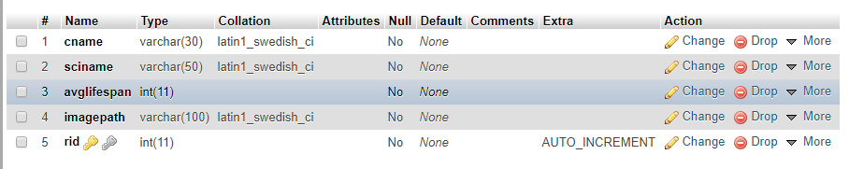

Cell table

